PHP 3rd Semester
Assignment - One
08th August 2025
Name: Saksham Srivastava
Class: 3A
Enr No: 05617702024

Q1. Declare and Print Variables
1. Create a PHP file named variables.php.
2. Declare the following variables:
- A string variable named $name with your full name.
- An integer variable named $age with your age.
- A float variable named $marks with your average marks.
- A boolean variable $status set to true.
3. Use echo to print each variable with a suitable message.
Expected Output:
Name: Rajan Dua
Age: 21
Marks: 85.5
Status: 1

Source Code
<?php
// Declaring variables
$name = "Rajan Dua"; // String
$age = 21; // Integer
$marks = 85.5; // Float
$status = true; // Boolean

// Printing variables
echo "Name: $name<br>";
echo "Age: $age<br>";
echo "Marks: $marks<br>";
echo "Status: $status<br>"; // Boolean true will print as "1"
?>

Output
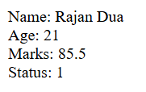

Q2. Explicit Type Casting
1. Create a file `type_casting.php`.
2. Declare a float value and cast it to an integer.
3. Convert a string to an array, a boolean to an
integer, and a number to a string.
4. Use `echo` and `gettype()` to display values and
types after casting.
Expected Output:
Original float: 45.78
After casting to int: 45
String to array: Array ( [0] =&gt; PHP )
Boolean to int: 1
Int to string: &quot;100&quot; (string)

Source Code
<?php
// Original float
$floatVal = 45.78;
echo "Original float: $floatVal<br>";

// Casting float to int
$intVal = (int)$floatVal;
echo "After casting to int: $intVal<br>";

// String to array
$str = "PHP";
$arrayVal = (array)$str;
echo "String to array: ";
print_r($arrayVal);
echo "<br>";

// Boolean to integer
$boolVal = true;
$boolToInt = (int)$boolVal;
echo "Boolean to int: $boolToInt<br>";

// Integer to string
$num = 100;
$numToStr = (string)$num;
echo "Int to string: \"$numToStr\" (" . gettype($numToStr) . ")";
?>

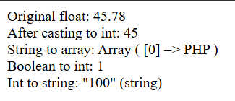
Output

Q3. echo with HTML Tags
1. Create a PHP file echo_html.php.
2. Use echo to output HTML content such as:
- Headings (&lt;h1&gt;, &lt;h2&gt;)
- Paragraphs
- Line breaks
Expected Output in Browser:
Welcome to PHP Lab (as heading)
This is a paragraph. (as paragraph)
Line 1
Line 2

Source Code
<?php
echo "<h1>Welcome to PHP Lab</h1>";
echo "<p>This is a paragraph.</p>";
echo "Line 1<br>";
echo "Line 2";
?>

Output
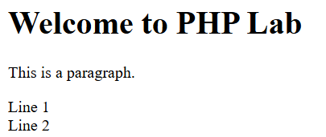

Q4. Type Juggling
1. Create a file `type_juggling.php`.
2. Assign a string containing a number (e.g.,
&quot;100&quot;) to a variable.
3. Add the string to an integer, and observe the
result.
4. Use `gettype()` before and after operations to
track how PHP changes the type.
Expected Output:
Before addition: string
After addition: integer
Result: 150

Source Code
<?php
$value = "100"; // String containing number

// Before addition
echo "Before addition: " . gettype($value) . "<br>";

// Adding string to integer
$result = $value + 50; // PHP will convert string to number automatically

// After addition
echo "After addition: " . gettype($result) . "<br>";
echo "Result: $result";
?>

Output
